Data Scrapping
A project file submitted
For
Information technology
By
Deepesh singh
Roll n.o. 7
Under the guidance of
MR Praveen kumar Joshi

Evergreen senior secondary school (governed by educational welfare society)Tularampur,
District Nainital , uttarakhand,india
10 October 2021

Certificate
This is to certify that the project called Data Scrapping being submitted to Evergreen senior secondary school haldwani for the project work of Information Technology in record of the work carried by Deepesh singh under
Date. Supervisor
10 Oct .
MR Praveen joshi
TGT computer
Evergreen se sec school,Haldwani
Forwarded by
MR MS Parwal
Principal
Evergreen green senior secondary school

Abstract
Main objective of data scraping is to extract information from one or more websites and process it in simple structures as Spreadsheets,database or CSV files however,in addition to be very complicated task data Scrapping is resource and time consuming mainly when it is carried out manually previous studies has developed serval automated solutions the purpose of this article is to revisit the different existing web scraping approaches categories and tools but it's area of applications

Acknowledgment
I would like to express my special thanks of gratitude to my it teacher MR Praveen Kumar joshi for their guidance and help me in completing my project I would like to extend my gratitude to my principal sir MR MS Parwal and entire factually no has imparted considerable knowledge to me finally I express my gratitude to my parents for their continuous encouragement understanding and support
Deepesh singh

Introduction

1.1what is data Scrapping
Web Scrapping consists in gathering data available on websites this can be done manually by human user or bot gather data much faster than a human user and that is why we are going to focus on this technically possible to collect all the websites

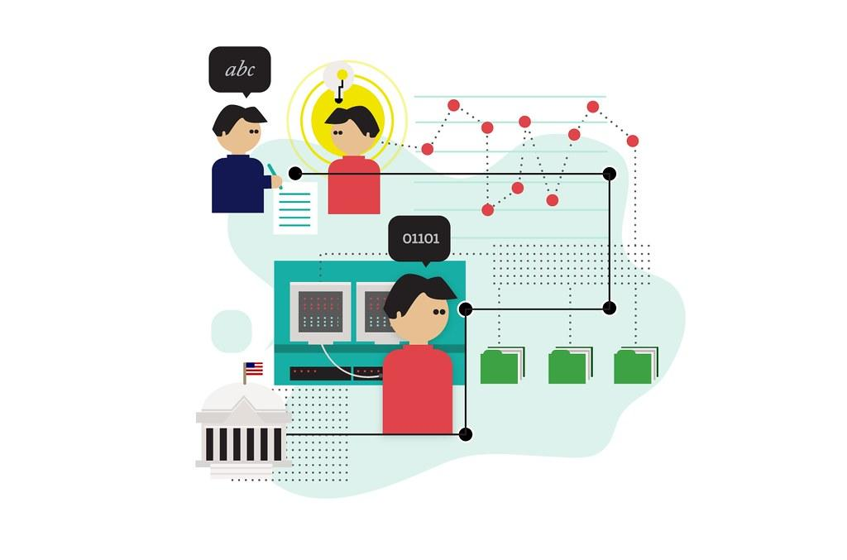

1.2 how does it work
Web scrappers gather websites data in the same way a human would do it the scrapper goes onto a web page of the website gets the relevant data .Every websites has a different structure that is why web scrapers are usually built to explore one website

2.what tools are we going to use
In this way we are going to use the python module request and beautiful soup.request will allow us to sent HTTP request to get HTML files

3. python
Python is an interpreted high level general purpose programming language it support multiple programming language including structured object oriented and functional programming

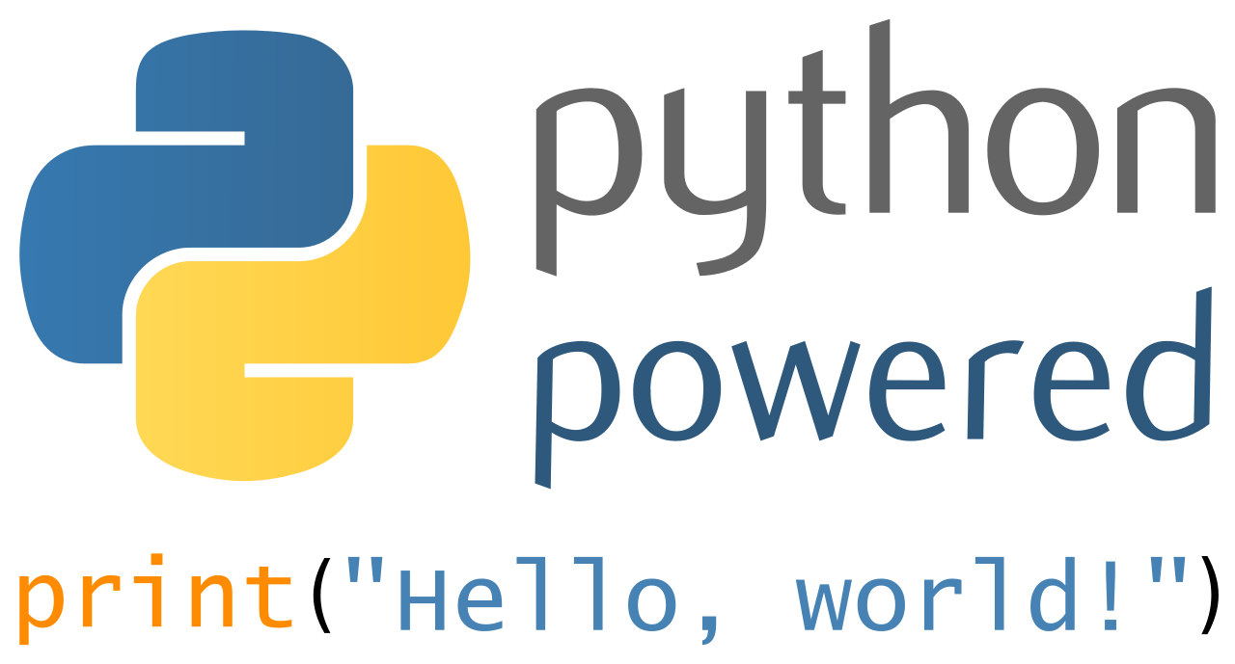

4.price monitoring division(pmd)

Price monitoring division in the department of data Scrapping is responsible for monitoring prices of selected essential commodities the activities of the division Include monitoring of the retail and wholesale prices and swot and future prices of selected essential commodities on a daily basis

4.1 price monitoring
Price monitoring for twenty two essential commodity rice,wheat,Dal,arhar,tomato,potato,vanaspati and salt based on the data collected from 167 market centre spread a cross the country represent north ,west,east ,south
4.2 source of price data
Retail and wholesale price of 22 commodities from 167 centres re received daily from the state civil supplies government through mobile apps developed by the department
4.3 price analysis
The prevailing price situation as well as factors which impact on prices ,in both domestic and international market are situated and brought to notice of high level committee such as COS,CCEA through agenda notes prepared for their meetings for appropriate action at the policy level .
4.4 market intervention scheme
Regular retail price reviews have been instrumental in deciding on strategies for market and ensure that shortages do not adversely affect the consumer particularly the vulnerable section of the population

Reference and future work
In the near future data Scrapping will be one of the important tools in lead generation process the web scraping tool can make markets research of the particular product services and enormes benefits to offer in marketing field and it is safe to say that data Scrapping has became on essential kill to acquire in today's digital world not only for tech companies and only for technical positions

Table of contents

S.no | Topic | Page n.o
1 | Introduction | 1
2 | Certificate | 2
3 | Abstract | 3
4 | Acknowledgment | 4
1 | Data Scrapping | 5
1.1 | How does it work | 5-6
2 | What tools are we going to use | 6
3 | Python | 7
4 | Price monitoring division | 8
4.1 | Price monitoring | 8-9
4.2 | Source of pice data | 9
4.3 | Price analysis | 9-10
4.4 | Market investor schemes | 10
5 | Reference and future work | 11

List of figures

S.no | Figure | Page n.o
1 | Schools logo | 1
2 | Data scraping | 5
3 | Python | 7

